**Major Ranking system**

**Software Requirements Specification**

**Document**

ABC Team

Liu Zhuoqiu(0952594) Li jiaming(1025675)

Meng siyuan(1025752) Wang yu(1025876)

Date: 10/9/2019

Professor: Dr. Ya. Tang

 Version: 1 Date: (10/9/2019)

Table of Contents

1. Introduction 4

1.1 Purpose 4

1.2 Scope 4

1.3 Definition, Acronyms, and Abbreviations 4

1.4 Reference 4

1.5 Overview 5

2. Overall Description 5

2.1 Product Perpective 5

2.1.1 System Interfaces 5

2.1.2 Interfaces 5

2.1.3 Hardware Interfaces 8

2.1.4 software Interfaces 8

2.1.5 Communications Interfaces 8

2.1.6 Memory Constraints 8

2.1.7 Operations 8

2.1.8 Site Adaptation Requirements 9

2.2 Product Functions 9

2.3 User Characteristics 9

2.4 Constraints 9

2.5 Assumption and Dependencies 9

2.6 Apportioning of Requirements 9

3. Specific Requirements 10

3.1 External Interfaces 10

3.2 Function 10

3.2.1 Use Case:Login 10

3.2.2 Use Case:Search 11

3.2.3 Use Case:Administrator and the database 11

3.2.4 Use Case:Simple text mining 11

3.3 Performance Requirements 11

3.4 Logic Database Requirements 12

3.5 Design Constraints 12

3.5.1 Standards Compliance 12

3.6 Software System Attributes 12

3.6.1 Reliability 12

3.6.2 Availability 12

3.6.3 Security 12

3.6.4 Maintainability 13

3.6.5 Portability 13

3.7 Organizing the Specific Requirements 13

3.7.1 System Mode 13

3.7.2 User Class 13

3.7.3 Objects 13

3.7.4 Feature 14

3.7.5 Stimulus 14

3.7.6 Response 14

4. Change Management Process 14

5. Document Approvals 14

6. Supporting Information. 15

# 1. Introduction

## 1.1 Purpose

The purpose of this document is to present a detailed description of this system. It will explain the purpose and describe the architecture and interface for functional implementation in detail. The document is for the developers and the users of the system.

## 1.2 Scope

This system will be an application running on a Windows desktop for students in the college or undergraduates. This system will collect data from Zhihu website only. The data will be collected by the administrator. It will perform simple text mining to show users which college majors are (not) popular in China. It will give the users a view of the prospect of their career after graduating from their college.

## 1.3 Definition, Acronyms, and Abbreviations

<Major Ranking System>

The System name.

<Log In System>

The system is designed for the college students. So when the students should have an account and corresponding password to log in this system. It will record some information for the students.

<Search Engine>

The students can search the information of which college majors are (not) popular in China. When they search a major, it will give the result of some information of this major.

<ICE>

The Information Collect System.This engine will collect data from Zhihu website about college major. It will perform simple text mining and rank each major by some rules.

## 1.4 Reference

IEEE SRS Format.

## 1.5 Overview

This project provides a platform for students to search major information.

The second section, Overall Description section will give an overview of the product. It contains the use case in the use case diagram and list how the use case are intended to do.

The third section, Specific Requirements section focus on the detail of the function of this application. It is written for the developers.

# 2. Overall Description

## 2.1 Product Perpective

The product is totally self-contained

There are several software in the market. However, the system of these software is totally different from ours. The majors information are categorized by schools. Our software provide the information categorized by differences of major. The components of system are similar which are login system, database system, and search system.

### 2.1.1 System Interfaces

Our program choose VisualBasic, Java, and R language. 

### 2.1.2 Interfaces

(1) Login system: it provides login performance for rear stage and front stage, and judge the user’s permissions to manage users in the system.

(2) Front stage: students can search major information in this application.

(3) Rear stage: data collectors collect the information from Zhihu

From a user perspective, our software start with a 300*400 size login interface. There are two input areas, username and password, and two options, register and login,  in the interface. A new user can register a new account, and a user who has registered before can login directly. If the user choose the register option, it will show 600*700 register interface, which including username, password and confirm password.Then when the user successfully login to the system, the search page will be shown. The user can search the keywords in the search box, and there is a 400*500 rank box at the bottom of the search page.

The following pictures are user interface.

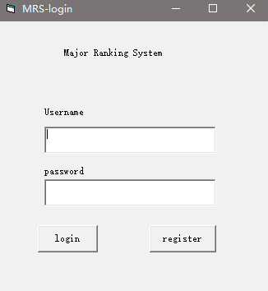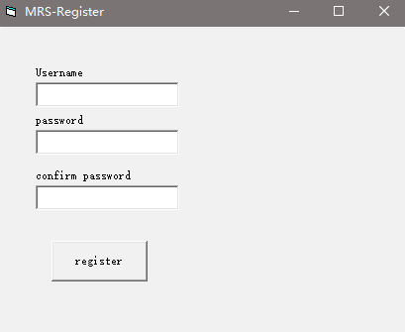

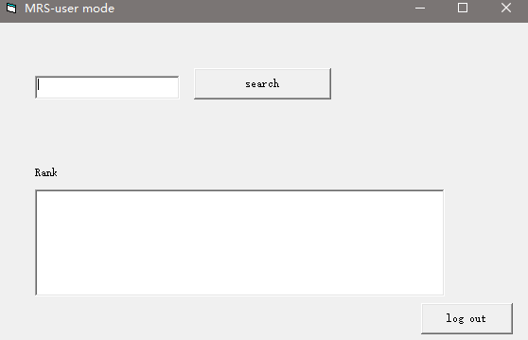

From an administrator's perspective, there is a rear stage page with 800*1000 size. In the left middle box, it is a backend input area with 300*400 size. There are three options around the input area, which user mode, data mining, and logout. In addition, there is a search page for administrator with 800*1000 size. In the upper level, there is a search box with 200*10 size. In the bottom level, there is a text box to display the rank information.

The following pictures are administrator interface.

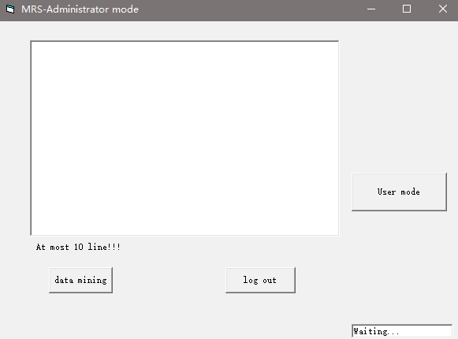

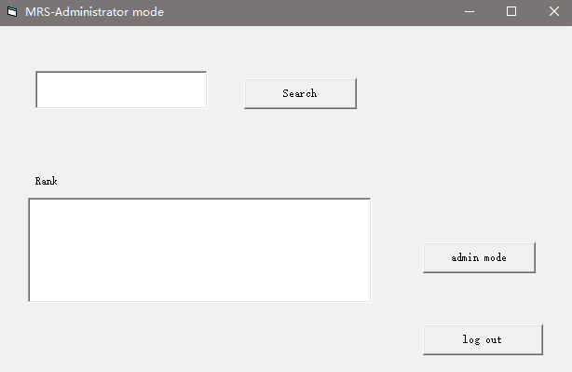

### 2.1.3 Hardware Interfaces

Our program doesn’t require the hardware interface.

### 2.1.4 software Interfaces

Until now, our application doesn’t require software interfaces.

### 2.1.5 Communications Interfaces

The website uses protocol to connect to the internet and establish the communication interface.

### 2.1.6 Memory Constraints

The memory of this website’s database is determined by the type of data stored in the database, the application software selected by the website, the product type, the number of products, and the amount of data accessed.

### 2.1.7 Operations

1. Registration : users register accounts with username and password
2. Login: users input username and password
3. Search: users search keywords in the search panel
4. Logout: users logout the system

### 2.1.8 Site Adaptation Requirements

Our application only get the data from the zhihu website, therefore, our application doesn’t require site adaptation.

## 2.2 Product Functions

The purpose of our product is to provide Chieses major and college information for students and parents.  Users can search some keyword to find the match information. In addition, the information also contain graduation rate, course pass rate, and career.

## 2.3 User Characteristics

The majority of our users are students who are applying to universities and their parents. Students and parents are curious about the universities ranking, major ranking, graduation rate, course pass rate, employment rate, and teaching resource. More importantly, users are willing to see the comparison among different universities and majors. Therefore, the software information should include these aspects.

## 2.4 Constraints

Our software using VisualBasic and R language. VisualBasic is used for the framework of software, and R language is used for collecting data. A few words have the same meaning, resulting in a large amount of engineering data collection. In addition, some professions do not have a detailed division, only the name of the department, resulting in inaccurate division.

## 2.5 Assumption and Dependencies

All of the information from Zhihu, the problem of Zhihu may affect our application.

The windows system is allowed, other system may cause some problems.

## 2.6 Apportioning of Requirements

The first version to delivery is to finish the basic function of the project, for example the text mining and search function. Make sure the basic function can satisfy users.

The future work of our project aim to apply our project to Android and IOS system, add more functions for our users and enhance the user experience.

# 3. Specific Requirements

This section requires detailed information about the software. Within the limitations of these detailed requirements, the software content can be fully contained.It can also be run and tested. Especially in this software, the user requires to provide keyword retrieval and external web indexing function, for the software input, output and database induction has a great demand. Besides, specific requirements should be stated with all the characteristics of a good SRS, which including correct, clear(unambiguous), complete, consistent, coherent, verifiable, modifiable,  traceable.

The program should set up a reasonable UI table according to the requirements of user keyword retrieval, such as title, author name or content retrieval classification for keywords, so as to reduce the unnecessary operation of the computer and improve the speed of operation.

## 3.1 External Interfaces

The Students and Administrator access the system by logging in through the Internet using specific username and password. If they don’t have correct account, they can’t log in the system.

The Students can search for the information of which college majors are (not) popular in China. They can select a major to find the popularity of this major in China.

Administrator can manual enter and verify the information into the system. They can add new information into the system. They can search and edit or delete some information stored in the system.

ICS should store the information and perform simple text mining and rank the major by their popularity in China. The results show that students are from this step.

## 3.2 Function

  The main purpose of this software is to help target groups to find the articles they need.This software includes login, search, administrator, the database and simple text mining.

### 3.2.1 Use Case:Login

The login function will connect to the user part of the data, and the user’s permissions, users’ name and passwords are saved in the data to support this function. Each time  using the function, connection would be settled for retrievement of data. Nonexistent user or unmatched password will not be allowed to further using the data. Besides, data of the user would be kept inaccessible for normal users to ensure the security of the user data. Besides, register function is also  encoded and only can be used by administrator permission.

### 3.2.2 Use Case:Search

Searching function is helping user to get the articles they need from Zhuhu. In this case, articles that would exhibit are specific. Users enter keywords to search related articles. Thus in order to reduce the occupied memory and raise the efficiency of application, keywords are divided into title keywords, author keywords and  content keywords. If searching the kinds of title or author, a view which contains author and author of the articles would firstly be retrieved and results would show to the user. Later if user select one of the results, direct jump or an index containing the original would be implemented. Otherwise, content keywords searching directly leads to data.

In this function, no result of searching will show 0 results. If there is a problem with connection to data, warning hint would be provided.

### 3.2.3 Use Case:Administrator and the database

Users are divided into different levels: normal users and administrators. Normal users have permissions of using application’s basic function, which are defined as the aim of the application. Administrator can access edition of application’s data, which can include user data, source of articles from Zhihu, view, which contains authors and titles of articles. Besides, Administrators have edit permissions. Administrators are also responsible for the quality of data that would be used. For example, articles saved in database can be limited(addition and delete).

Database are based on excel, which simplifies the input and output. User data part and article data part are distinguished easily and would not bother each other.

### 3.2.4 Use Case:Simple text mining

This use case allows the ICS performs simple text mining to rank rank the major by their popularity in China.

## 3.3 Performance Requirements

This system should support three users at least during the same time.

All of the results should be sent to the users in one minutes.

The results should be sorted by relationship of users’ searching keywords from high to low.

Display contents  are going to be realistic.

## 3.4 Logic Database Requirements

Article data saved in database should be sorted by major or article titles’ initial. Articles quoted in database should not be changed and keep the origin data.

## 3.5 Design Constraints

The articles in the software database are only allowed within the scope of zhihu articles.

### 3.5.1 Standards Compliance

The software supports the operation and compilation of Windows system. And the article content only allows the copy function, does not allow the edit function.The database will be limited to excel format to ensure uniformity.

## 3.6 Software System Attributes

### 3.6.1 Reliability

The content of articles in the database will be directly related to the content of articles in zhihu. Copying article data will be allowed in the software, but the content of articles and other accurate information will definitely not be allowed to change.

### 3.6.2 Availability

The application aims at retrievement  of articles from Zhuhu. Thus, it would be useful for students of reduce the time of searching demand.

### 3.6.3 Security

Use RSA cryptographic to protect the data away from the accidental or malicious destroy.

Save the log or history data sets as a document before changed

Only administrators can change the content. Users can only use The data.

static monitoring: when the program is not running,analysis the data stream and control stream.

Dynamic monitoring: during the program running, analysis the memory ,variable  and register.

Error manage and loophole response.

### 3.6.4 Maintainability

The code and database of application support alter. The application would be tested regularly to keep the stable of this application.

Application should provide the contact information of maintainer.

### 3.6.5 Portability

Because of the limitation of our project, it can only install into windows desktop to use.

The percentage of code that is host dependent is low. So, it is easy to portable to other host.

## 3.7 Organizing the Specific Requirements

### 3.7.1 System Mode

It is a Windows desktop system.

### 3.7.2 User Class

We have to class of our users.

One is the normal users, they can login our project and have the basic functions, for example the search and ranking function.

Another class is administration, not only the basic functions, but some specific function, for example, the administrations can update the content of our system, they can input some article to catch the necessary information.

### 3.7.3 Objects

We have five objects in our project.

Students: the username, password, address, phone number and search history

Administrator: the adName, password, address, phone number and search history

Major: majorname, major rank, school name and article name

School: school name, school rank  major name and article name

ArticleInZhihu: article name, website, school name and major name

### 3.7.4 Feature

**3.7.4.1 mouse effect**

When users put the mouse on the textbox, the color and box will change with no mouse on it. The user will have the feeling of that they put the mouse in the right place.

**3.7.4.2 response effect**

When users do some actions in our application, they system will change the color and do some effect to show users that they did something and the application reflect in our application.

### 3.7.5 Stimulus

When the system update or the Zhihu article update, the system will tell users and ask them refresh their application whether or not.

### 3.7.6 Response

The system will have the response when users do some actions on our application.

# 4. Change Management Process

If Users find any problem of our project, they can click a button named “help” to looking for our help. When the button is clicked, the system will send an email our project email address. Everyone who has this email will be informed. For now, the phone call may not be supported. If  our group be large, we will have a special person for receiving them. Otherwise, we have a log file to record every user’s problems and it will update to our group every three months. The change management will be applied after a meeting to consensus.

# 5. Document Approvals

Liu Zhuoqiu

Li Jiaming

Meng Siyuan

Wang Yu

Date 10/9/2019

# 6. Supporting Information.

We use the table of contents to make our SRS content look clearly.